Git init

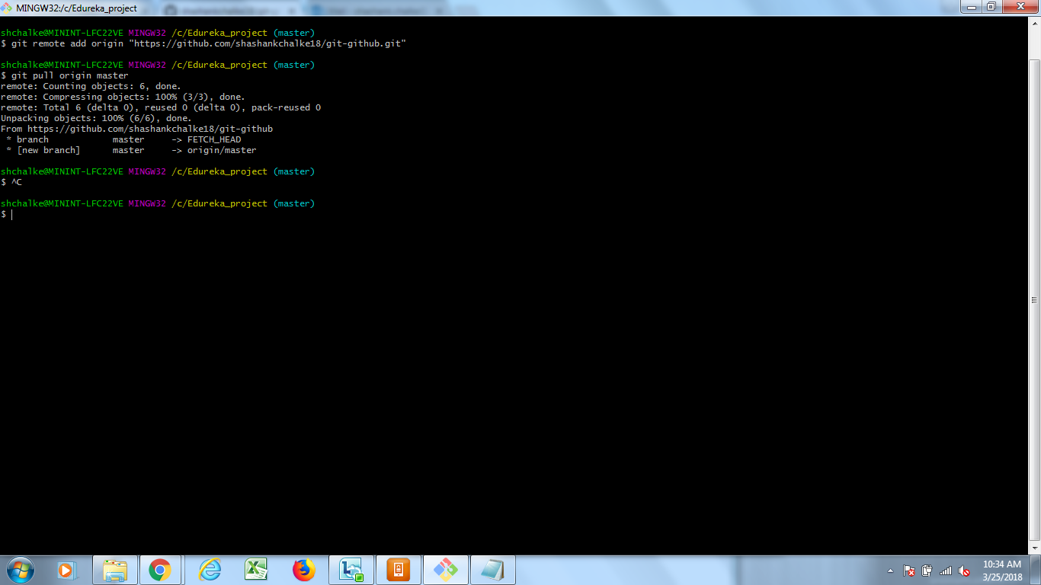

shchalke@MININT-LFC22VE MINGW32 /c/Edureka_project (master)

$ git remote add origin "https://github.com/shashankchalke18/git-github.git"

shchalke@MININT-LFC22VE MINGW32 /c/Edureka_project (master)

$ git pull origin master

remote: Counting objects: 6, done.

remote: Compressing objects: 100% (3/3), done.

remote: Total 6 (delta 0), reused 0 (delta 0), pack-reused 0

Unpacking objects: 100% (6/6), done.

From https://github.com/shashankchalke18/git-github

* branch master -> FETCH_HEAD

* [new branch] master -> origin/master

shchalke@MININT-LFC22VE MINGW32 /c/Edureka_project (master)

$ ^C

shchalke@MININT-LFC22VE MINGW32 /c/Edureka_project (master)

$ ^C

shchalke@MININT-LFC22VE MINGW32 /c/Edureka_project (master)

$